- Execute the commands to display, count and edit the content of file f2
- cat f2 [ To display the content of file f2 ]
- cat -n f2 [ To display the content of f2 with line numbers ]
- wc f2 [ To display the number of lines, words and characters in f2 ]
- wc -l f2 [ To display only the number of lines in f2 ]
- wc -w f2 [ To display only the number of words in f2 ]
- wc -m f2 [ To display only the number of characters in f2 ]
- wc -L f2 [ To display the length of the longest line in f2 ]
- vi f2 [ To open f2 in vi editor and insert a new blank line ]
- cat -n f2 [ To verify the updated content of f2 after editing ]
- wc -l f2 [ To recount the number of lines after editing ]
- wc f2 [ To recount the lines, words and characters after editing ]
- wc -m f2 [ To recount the number of characters after editing ]
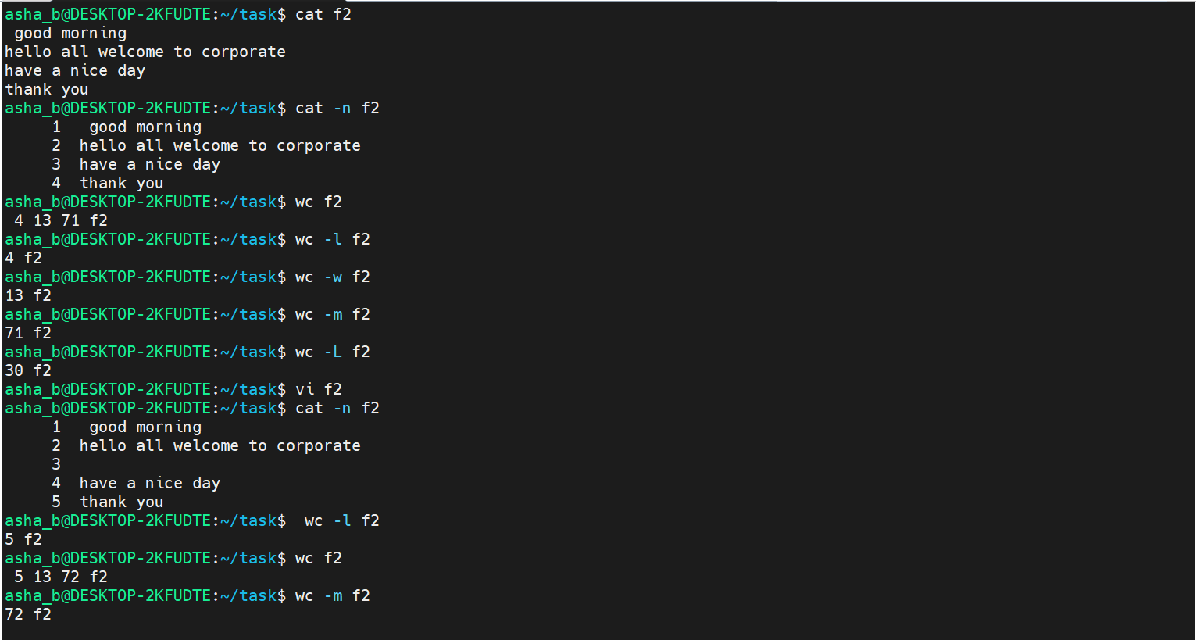
- Execute the command :
- cat -n unique [ To display the content of unique with line numbers ]
- head unique [ To display the first 10 lines of unique by default ]
- head -4 unique [ To display only the first 4 lines of unique ]
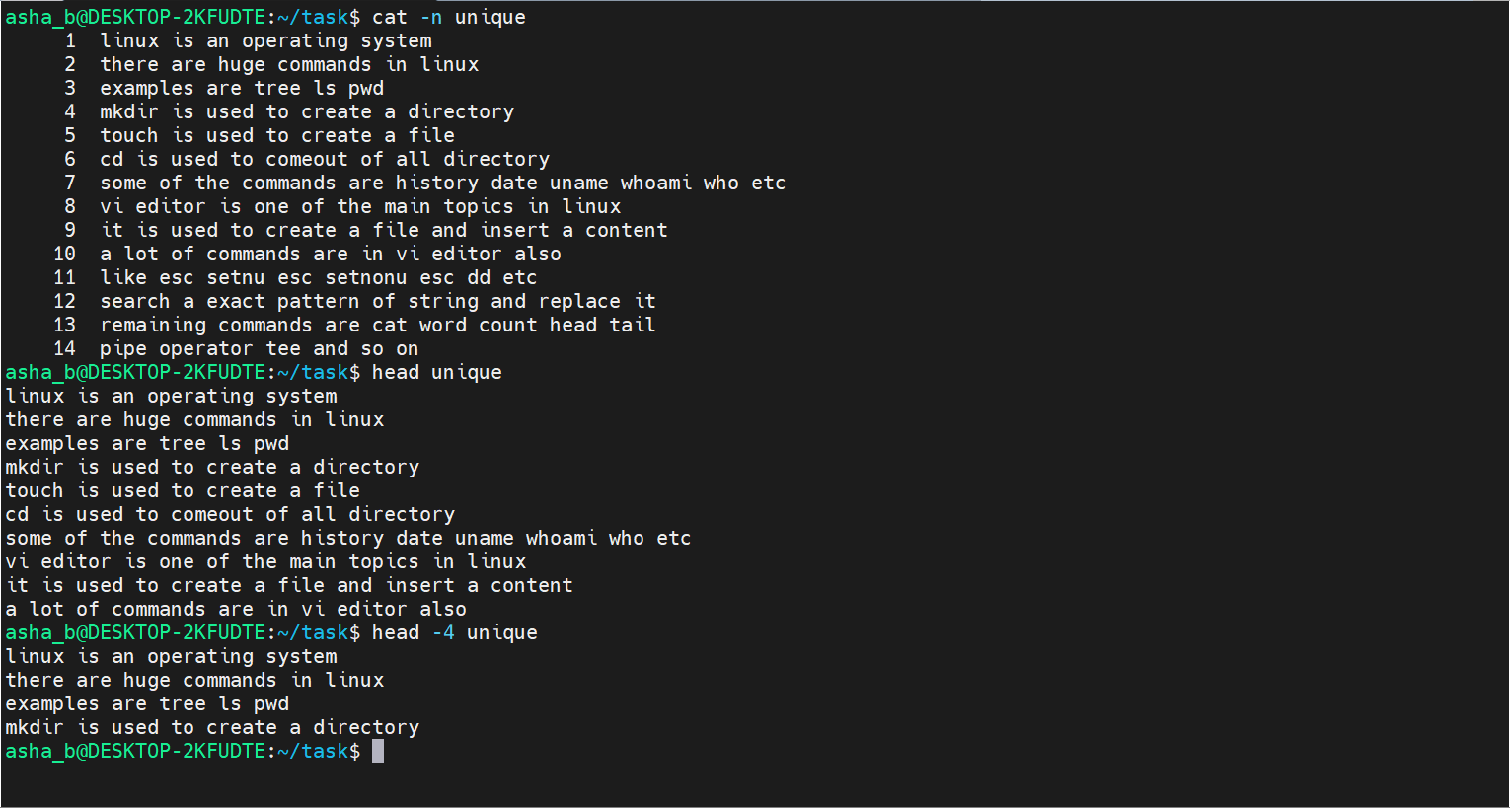
- cat -n f2 [ To display the updated content of f2 with line numbers ]
- head f2 [ To display the first 10 lines of f2 by default ]
- head -4 f2 [ To display only the first 4 lines of f2 ]
- tail f2 [ To display the last 10 lines of f2 by default ]
- tail -3 f2 [ To display only the last 3 lines of f2 ]
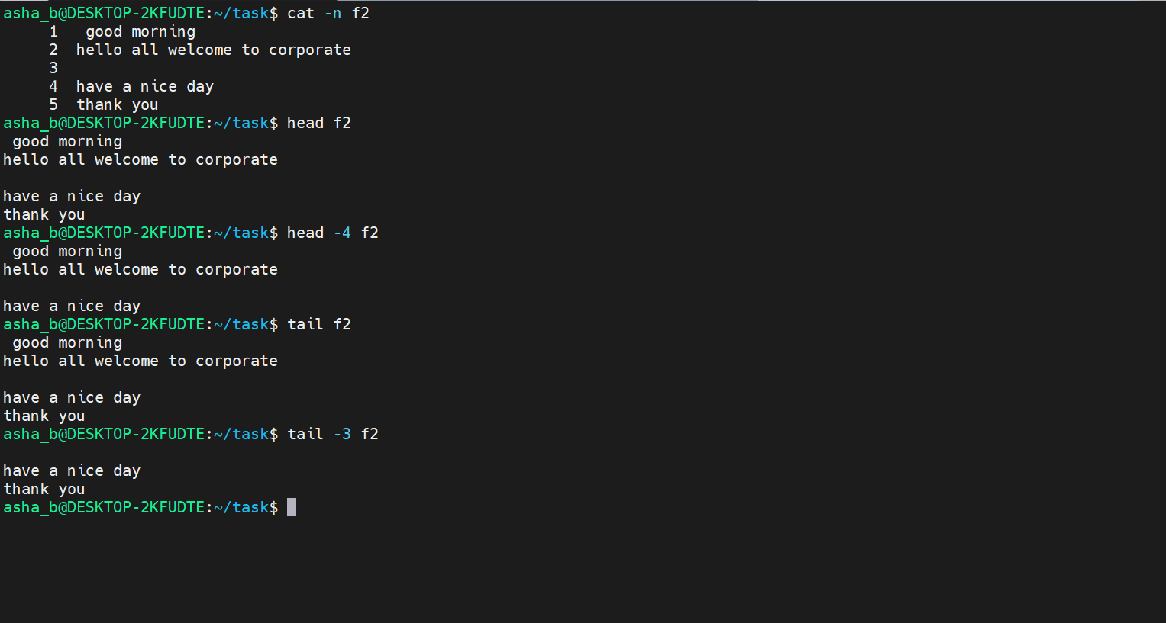
- Execute the command :
- cat -n unique [ To display the content of unique with line numbers ]
- tail unique [ To display the last 10 lines of unique by default ]
- tail -2 unique [ To display only the last 2 lines of unique ]
- tail -1 unique [ To display only the last line of unique ]
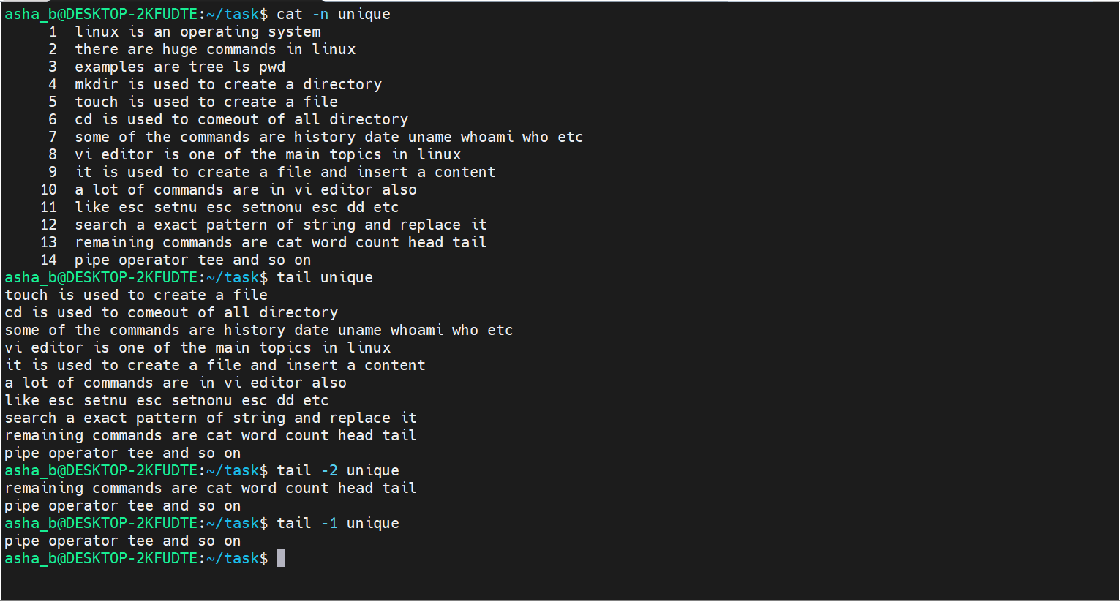
- Execute head and tail combined with pipe operator to extract specific lines of unique
- cat -n unique [ To display the content of unique with line numbers ]
- head -12 unique | tail -3 [ To display lines 10 to 12 of unique ]
- head -5 unique | tail -1 [ To display only the 5th line of unique ]
- tail -8 unique | head -4 [ To display lines 7 to 10 of unique ]
- tail -10 unique | tail -1 [ To display only the last line of unique ]
- head -4 unique | head -1 [ To display only the first line of unique ]
- cat -n unique | tail -2 [ To display the last 2 lines of unique with line numbers ]
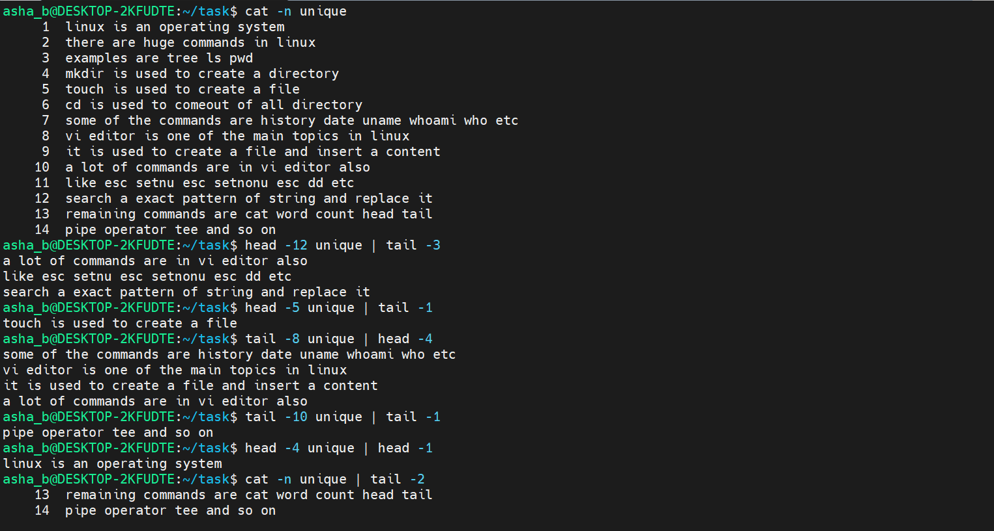

- Execute the command : nl and ls with pipe to number lines and count files
- cat -n f2 | tail [ To display the last 10 lines of f2 with line numbers ]
- cat -n f2 | head -4 | tail -8 [ To display the content of f2 after chaining head and tail ]
- head -3 f2 | nl [ To number the first 3 lines of f2 using nl ]
- head f2 | nl [ To number the first 10 lines of f2 using nl ]
- tail -4 f2 | head -3 | nl [ To number selected lines of f2 after chaining tail and head ]
- ls [ To list the files in the current directory ]
- ls | wc -l [ To count the number of files in the directory ]
- ls | wc -w [ To count the number of words in the ls output ]
- ls | wc -L [ To display the length of the longest file name ]
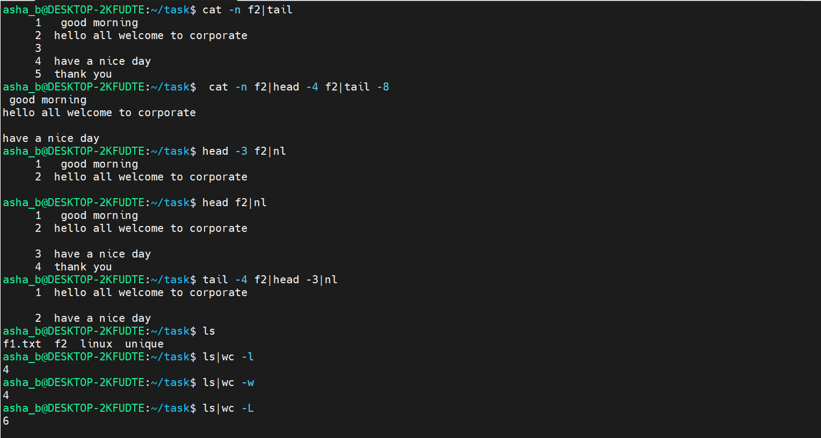
- Execute the command : tee to save displayed content into another file
- cat linux [ To display the content of file linux, which is currently empty ]
- cat -n unique [ To display the content of unique with line numbers ]
- cat -n unique | tee linux [ To display the numbered content of unique and save it into file linux ]
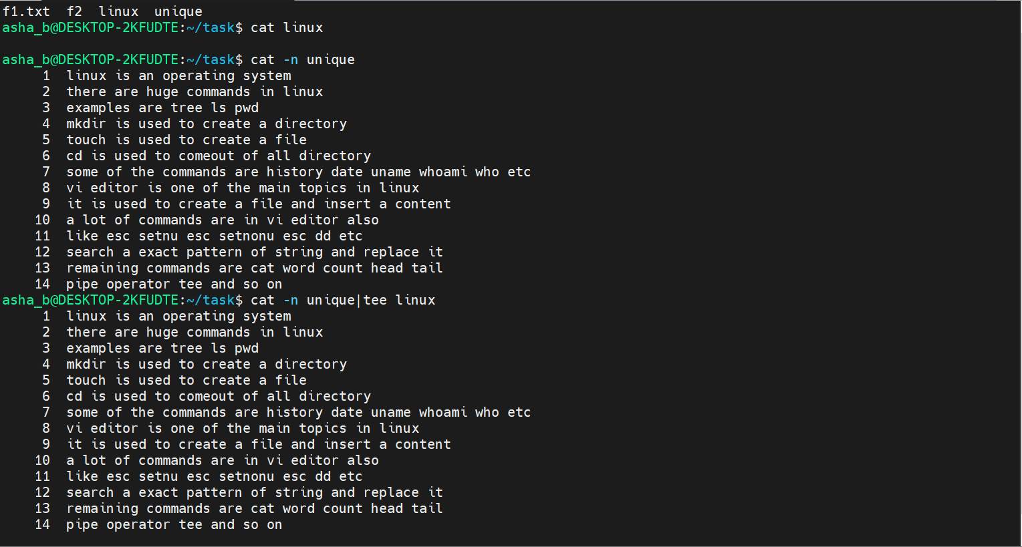
- Execute the command : tee to overwrite the content of file unique
- cat -n unique [ To display the content of unique with line numbers ]
- cat -n f2 [ To display the content of f2 with line numbers ]
- cat -n f2 | tee unique [ To display the numbered content of f2 and save it into file unique ]
- cat -n unique [ To verify that unique now contains the numbered content of f2 ]
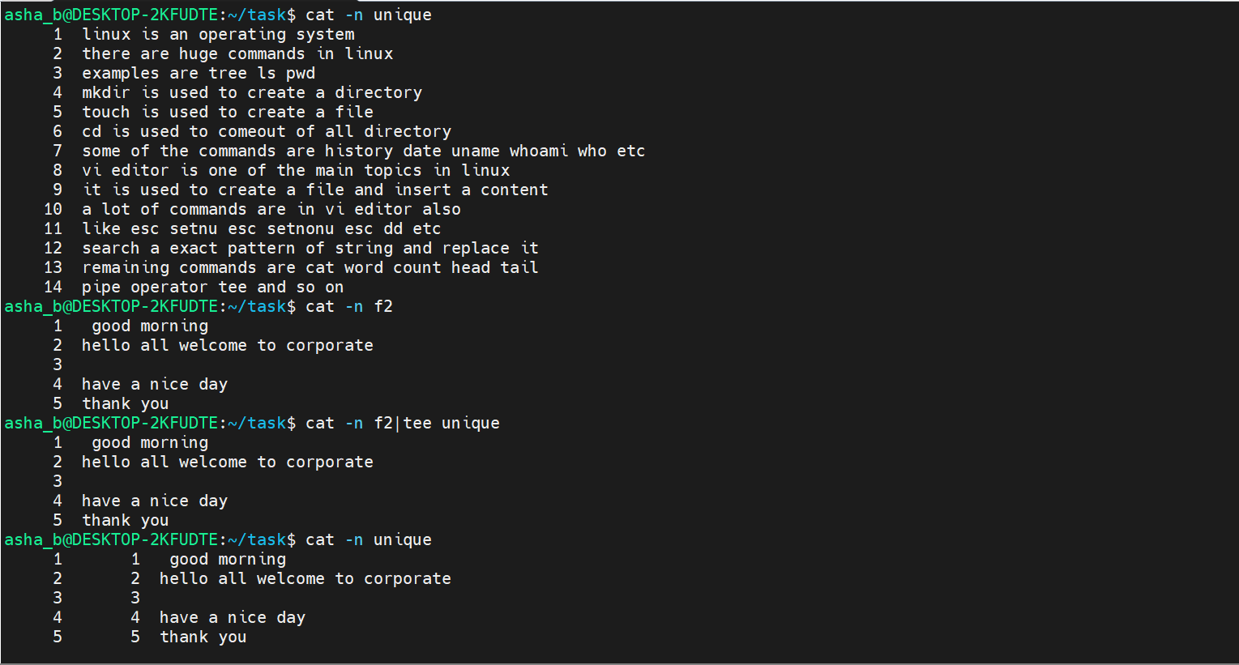
- cat f2 [ To display the original content of f2 ]
- cat unique [ To display the current content of unique ]
- cat f2 | tee unique [ To overwrite unique with the content of f2 using tee ]
- cat unique [ To verify unique now matches the content of f2 ]
- cat -n unique [ To display the updated content of unique with line numbers ]
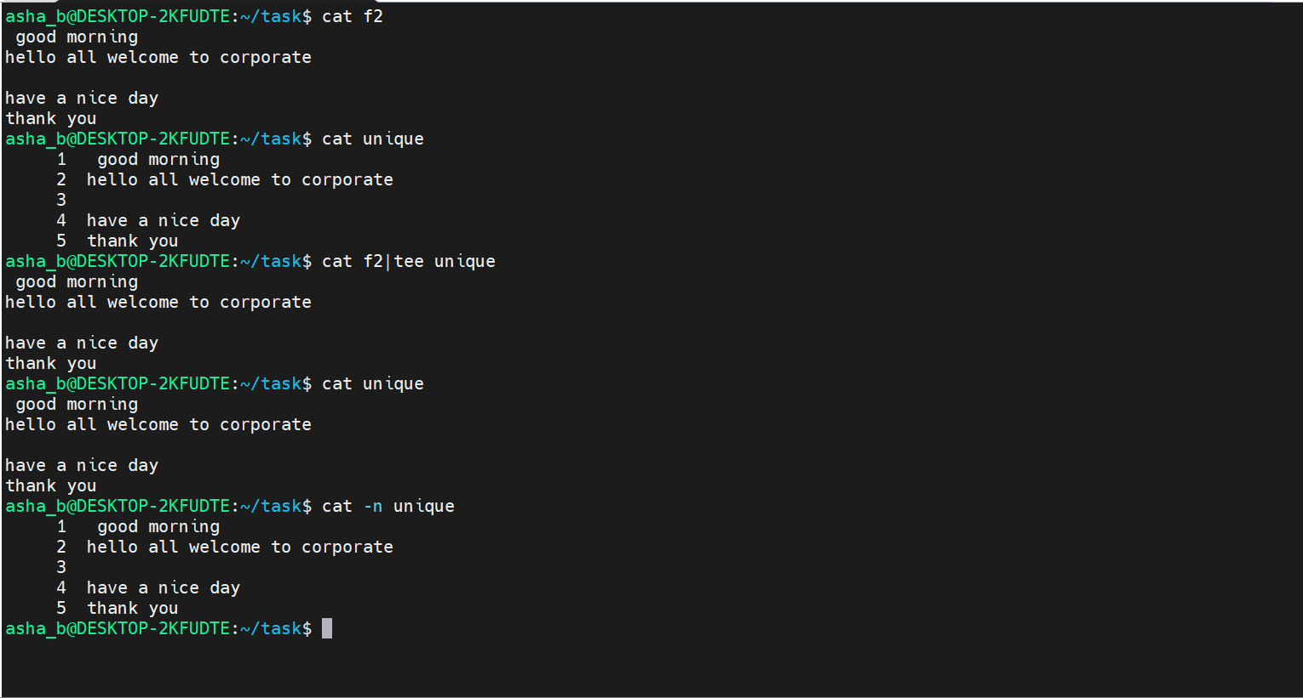
- Execute the command : ls and tee to save command output into new files
- ls [ To list the files in the current directory ]
- ls | tee unique [ To list the files and save the output into file unique ]
- cat f2 [ To display the content of f2 ]
- tail -2 f2 | tee f1.txt [ To save the last 2 lines of f2 into file f1.txt ]
- head -1 f2 | tee f1 [ To save the first line of f2 into a new file f1 ]
- ls [ To verify the new files f1 and f1.txt are created ]
